**Evolution of resistance to antibiotics on a cellular level**

Tom Wilson

*School of Computing*

*Teesside University*

*S6051830@live.tees.ac.uk*

Lewis Carroll

*School of Computing*

*Teesside University*

*Q5108757@live.tees.ac.uk*

Andrew Fenney

*School of Computing*

*Teesside University*

*Q5277787@live.tees.ac.uk*

Andrew Richardson

*School of Computing*

*Teesside University*

*P4053489@live.tees.ac.uk*

Lok Wai Tony Chan

*School of Computing*

*Teesside University*

*V8191963@live.tees.ac.uk*

Keywords: Evolution of resistance to antibiotics on a cellular level, COM3036-N

# Abstract

Drug resistance to antibiotics is a serious problem in healthcare today as fewer drugs are becoming available to effectively treat bacterial infections, thus leading to some illnesses being rendered untreatable.

This paper investigates disease spread and the evolution of drug resistance using agent-based modelling. In particular, we will investigate the Staphylococcus aureus bacteria becoming resistant to the drug methicillin, resulting in the strain methicillin-resistant Staphylococcus aureus (MRSA) emerging. We examine how through horizontal gene transfer and selection pressure, resistance develops in a population of bacteria, and analyse the different emergent patterns we begin to notice when simulating disease spread. We will identify key reasons why antibiotic resistance occurs using data collected from automated simulations, and provide possible solutions to the growing epidemic.

# 1. Introduction

Methicillin was first introduced in 1959 to treat infections that had become resistant to penicillin - by the early 1960s, there were already reports of S. aureus acquiring resistance to methicillin in the United Kingdom (Enright et al, 2002). This posed a serious problem, as new antibiotics typically take 10 to 20 years to be discovered, tested, and made available (Jinks, 2017) - as the population grows, bacteria become resistant and kill faster than we can develop new antibiotics. This paper aims to identify the causes for bacteria becoming resistant and to provide possible solutions to slow down resistance using data acquired from computer-aided modelling.

During this paper we aim to prove the hypothesis that through horizontal transfer and natural selection, Staphylococcus aureus will always trend towards becoming resistant to methicillin, resulting in methicillin-resistant Staphylococcus aureus (MRSA) evolving. It is expected that when an initially small population of non-resistant and resistant bacteria are exposed to antibiotic, the total population will grow and resistance will become dominant throughout the population, eventually reaching total immunity.

Prior to building an agent-based model to simulate the hypothesis, research was conducted to explore how antibiotic resistance and the motility of S. aureus had been studied in real-life laboratories previously, as to build a more accurate simulation. Historically, S. aureus had been regarded as non-motile or only mobile through passive fluid movement, meaning it could not move; however, more recently, it has been shown that under certain circumstances it is possible for apparent movement to occur during colony multiplication through a process known as spreading (Pollitt et al, 2015). Dendrites - a branching tree-like structure - typically form as the bacteria spread, as was demonstrated in the figure below.

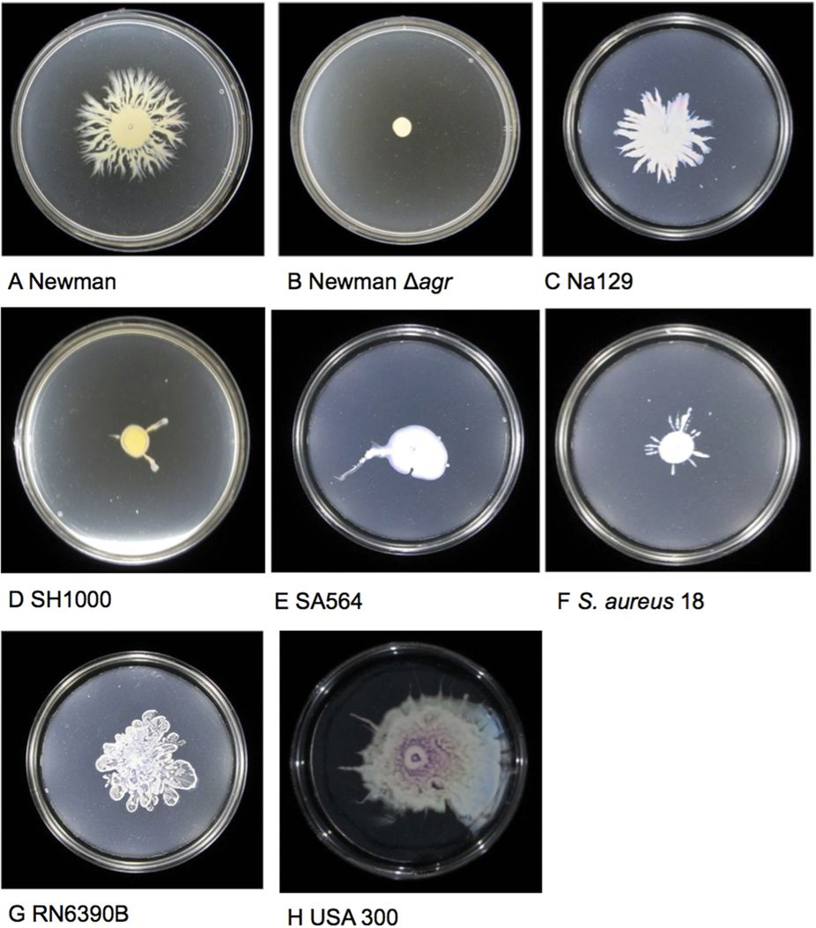

***Figure 1: Spreading of S. aureus (Pollitt et al, 2015)***

S. aureus develops resistance to antibiotics primarily via a mechanism of horizontal gene transfer called conjugation - this is where genetic material is passed between bacteria by direct cell-to-cell contact. A bacterium containing a self-replicating circle of DNA called a plasmid comes together with another bacterium, and the plasmid is copied into it. This plasmid contains the gene that enables resistance to a particular antibiotic. The receiving bacterium may incorporate some of the DNA it took into its genome, and pass that along to its descendants (University of California Museum of Paleontology, 2008).

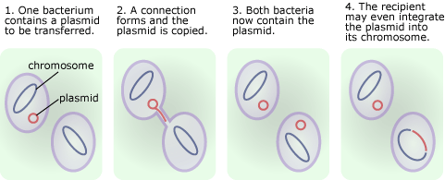

***Figure 2: Horizontal Gene Transfer (University of California Museum of Paleontology, 2008)***

Modelling antibiotic resistance with a computer-based simulation allows us to adjust parameters and run a large number of tests to give sufficient data in order to identify methods of slowing down resistance. This is much more cost effective compared to real life in-laboratory experiments where equipment needs to be bought in, and antibiotic procured. Furthermore, the more we use antibiotics, the more they evolve - by confining experiments to a computer simulation, we are not adding to the epidemic of antibiotic resistance on a global scale.

# 

# 2. Agent-Based Modelling

To prove the hypothesis, an experiment was devised using agent-based modelling via the NetLogo modelling environment. The model was designed to simulate a real-world test of bacterial spread within a Petri dish, where methicillin would be applied several times to the set agar jelly, and bacteria exposed. The NetLogo model replicated this by generating a number of patches randomly in either a distributed fashion or in clusters to simulate antibiotic being applied with a pipette - the generation was user controlled with a switch named **clustered-antibiotics**. The generated antibiotic patches were coloured in red to distinguish from non-antibiotic patches.

In order to generate the antibiotics in a cluster pattern the algorithm detailed below first selects a random patch, then chooses a radius between one and four patches. Each patch in this selected radius then has a 70% chance of becoming an antibiotic patch. This continues until at least the specified number of patches has been reached, if the algorithm overshoots the target the surplus are removed at random from the collection of antibiotic patches.

while [antibiotic > (count patches with [pcolor = red])][

ask one-of patches[

ask patches in-radius one-of [1 2 3 4][

if (random 10 < 7) [set pcolor red]]]]

ask n-of ((count patches with [pcolor = red]) - antibiotic)

patches with [pcolor = red] [set pcolor black]

Bacteria (referred to as turtles in the NetLogo environment) were generated randomly, again using user-controlled variables and placed into the world. To differentiate between bacteria with and without resistance to antibiotics, they were assigned different colours - non-resistant bacteria were coloured blue, and resistant bacteria were coloured green. In reality, there are many strains of resistant and non-resistant S. aureus, but the simulation was simplified to use only two types of agent.

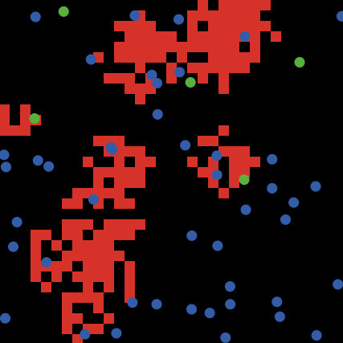

***Figure 3: Randomly generated starting state of NetLogo model***

The user could control the number of antibiotic patches that would be generated (***antibiotic***), the number of starting bacteria (***num-bacteria***), the percentage of the population generated resistant already (***resistant-chance***), and the percentage chance that a bacterium would swap its genetic material with another bacterium during conjugation (***conjugation-bias***).

The model enforced limits on population size by checking for overpopulation in the area around each bacterium - when the immediate area (roughly one bacterium length) around a bacterium contained greater than seven neighbours it would die from overcrowding. This was done partially for performance reasons but also because in reality the limited resources and space would lead to competition between neighbouring bacteria and as a result some bacteria will fail to obtain the resources sufficient to reproduce. The below line of code was used to enforce this maximum population density and it ran upon all turtles every tick.

if(count other turtles in-radius 1 >= 8)[die]

During modelling, a number of assumptions were made - firstly, antibiotic did not deplete over time, nor did it move between patches. Secondly, there was an assumption that a capped, frequently replenished (every tick) amount of food was provided for the bacteria, meaning that while the bacteria as a whole will never starve, individuals are capable of being out-competed by their neighbours. With this assumption made the model used the overpopulation mechanism as outlined above as a simplification of the competition for resources.

The bacteria moved by spreading, forming dendrites as has been observed in the real world. The model was non-deterministic with similar overall results appearing with each run. The dendritic spreading mechanism was implemented by nudging each bacterium along slightly when they undergo mitosis so the resultant two bacteria are touching edge-to-edge instead of atop one-another. Each tick one third of the bacterium are also asked to rotate a random amount between 0 and 360 degrees as mitosis wouldn’t be confined to occuring only along a specific axis. Initially all bacteria rotated randomly each tick, however during the course of some tweaks for the sake of performance it became clear that not only did the model perform better with less random numbers being generated each tick but also it started to behave and look more like could be expected from a developing colony of bacteria. The below code is responsible for the dendritic behaviour.

ask n-of (count bacteria / 3) bacteria [wiggle]

to wiggle right random 360 end

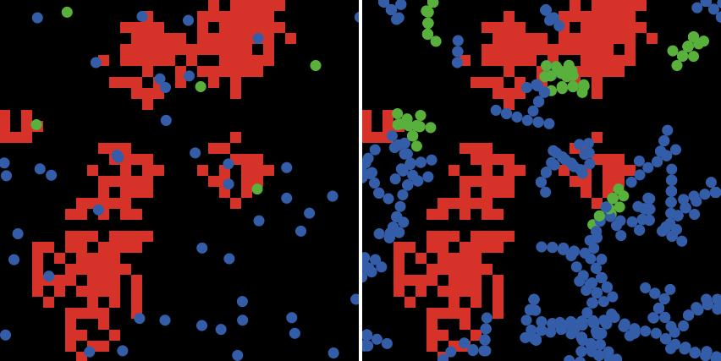

***Figure 4: Bacterial spread after 4 generations***

Bacteria were non-cognitive agents, so their movements did not exhibit any kind of deliberate cooperation, although they did exchange genetic material by accidentally encountering other agents in their immediate vicinity.

The bacteria were non-reactive and non-communicative. They made no deliberate attempt to avoid antibiotic patches in their movements and did not warn other agents of the danger, although there was limited agent-agent interaction in conjugation leading to resistance. Agents were non-learning, their behaviour was not adjusted based on prior experience. (Glavic, 2006)

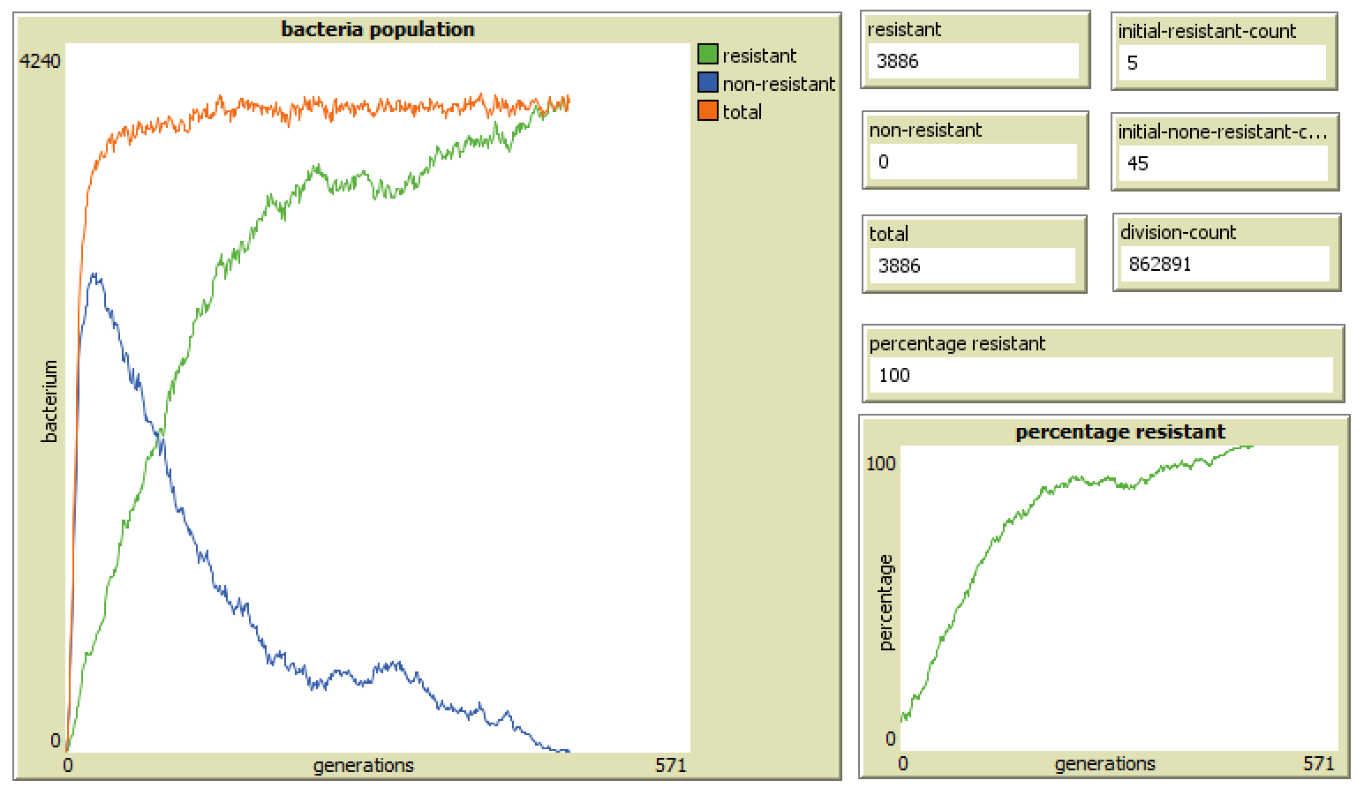

***Figure 5: Statistics readouts***

To aid in the observation of behaviours exhibited by the model, some graphs and counters were implemented. The main graph pictured above shows the total population and the count of each population group (resistant and non-resistant) over time. This graph showed a clearer picture of the quantity of each population group as it can be hard to tell at which point the majority of bacteria become resistant when looking at the NetLogo viewer due to bacteria being displayed on top of, or in extreme proximity to, each other. The other graph show to the right simply shows the percentage of the population currently resistant over time. The counters track the initial quantity of bacteria placed during set-up (**initial resistant-count**, **initial-none-resistant-count**), the current numbers of bacterium both resistant and non-resistant, and also in total (**resistant**, **non-resistant**, **total**). The remaining two counters **division-count** and **percentage resistant** show the total number of times mitosis has occurred and the value of the size of the resistant population as a percentage, respectively.

Another small addition to the model made for the purposes of making observation easier is the **auto-stop**, when enabled **auto-stop** will pause the execution of the model if either segment of the population reaches zero. This was added as no data after the point at which either all of the population is resistant or nonresistant is particularly useful, so there was no purpose in collecting it.

**3. Results**

NetLogo is a powerful piece of software for computer-aided modelling, especially when using BehaviourSpace. BehaviourSpace is a tool that allows for experiments to be performed on models built in the NetLogo environment, often repeating the same experiment to get a larger range of data to analyse. Additionally, it allows for different experiments to be run where certain parameters could be tweaked; for example, an experiment was run where the number of antibiotic patches was changed to analyse how the rate of resistance changed. When using a computer with multiple processor cores, the experiments can be run in parallel, which reduces the time required to collect data for analysis.

A number of experiments were run on the model to analyse changing speeds of resistance uptake, and to identify methods of slowing down antibiotic resistance. The first experiment was primarily changing the number of antibiotic patches as mentioned previously - the BehaviourSpace experiment setup consisted of the default variables identified as being ideal when building the model remaining the same, with the antibiotics set to 10, 50, 100, 200, 400, and 500. Each experiment was run 10 times resulting in 60 sets of data.

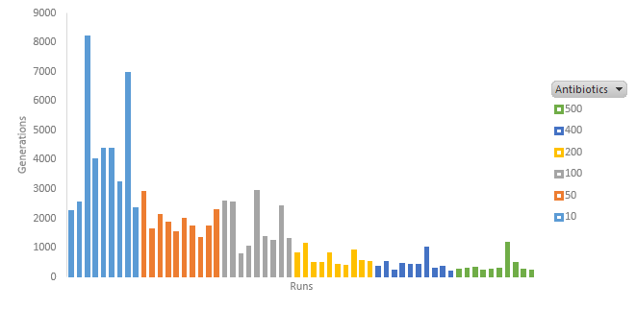

***Figure 6: Generations until resistant with varying antibiotic amounts***

The results showed a strong correlation between the number of antibiotic patches and the speed at which a population of bacteria becomes resistant. As the number of patches increased, the speed of resistance increased. The data was corrected to eliminate two anomalies where the generation count was significantly lower than other experiments with the same variables - this was due to the simulation ceasing early as the population reached 0% immunity. As the resistant bacteria had died out, there was nothing to conjugate with the non-resistant bacteria, so immunity could not be reached.

Interestingly, the correlation did not seem to be linear, and instead trended towards an exponential speed increase as the number of antibiotics were increased. This was made clearer by averaging the data from the 6 groups of 10 runs and plotting the results onto a line graph.

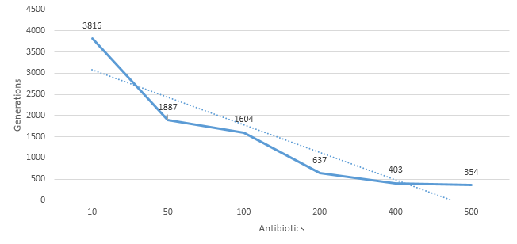

***Figure 7: Average generations until resistant with varying antibiotic amounts***

As was evident from the graph, the difference in generations between 200 and 500 antibiotics was 283, whereas the difference between 10 and 50 antibiotics was 1,929 - that was a far more substantial difference, especially given the difference in antibiotics was much fewer.

This data reinforces the point made by Ventola (2015), in that the overuse of antibiotics drives the evolution of resistance, and that there is a direct relationship between antibiotic consumption and the emergence of resistant strains of bacteria.

Following on from this experiment, another was devised using the same parameters, only switching antibiotic clustering off, so antibiotics were placed at random. This was akin to the real world scenario of an antibiotic/bacteria solution such as within the bloodstream.

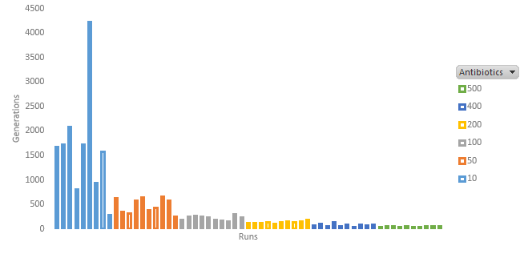

***Figure 8: Generations until resistant with varying antibiotic amounts (without clustering)***

As with the previous experiment, this resulted in an exponential increase in speed as the number of antibiotics were increased. Again, this has been shown on a line graph by averaging the results from all 60 runs.

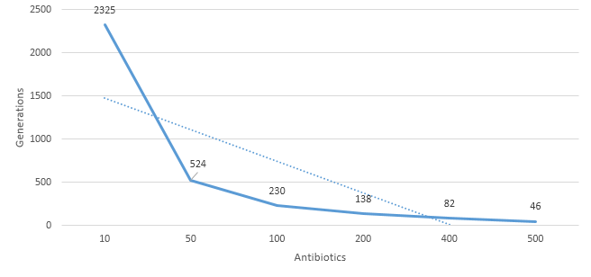

***Figure 9: Average generations until resistant with varying antibiotic amounts (without clustering)***

When in a solution, resistance evolved much faster than in a Petri dish with clusters of antibiotics as the data demonstrates. Whilst both experiments followed similar trend lines, the random placement of antibiotics in the second experiment meant that the bacteria evolved much faster, a difference of 48.6% when 10 antibiotics are used, and a difference of 154% when 500 antibiotics are used. A comparison of averages from both experiments was developed:

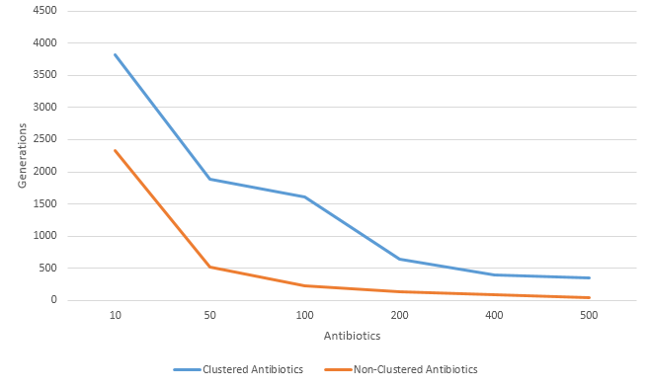

***Figure 10: Comparison of average generations between clustered and non-clustered antibiotics***

Some emergent behaviour was observed when antibiotic clusters were used in the simulation; resistant bacteria would populate on these areas and as they spread out they would conjugate with non-resistant agents on the borders resulting in resistant bacteria. When comparing both the non-clustered and clustered experiments it was clear that the experiment using non-clustered antibiotics caused a higher amount of activity relating to the antibiotics themselves - this is due to the fact the antibiotics were more spaced out within the Petri dish, covering a larger surface area.

As a result of this, the bacteria within the simulation were more likely to come into contact with the antibiotics, causing any bacteria that were non-resistant to die which lowered the amount of time taken to achieve 100% resistance. This was proven in ***Figure 9***, which showed that the non-clustered antibiotics experiment had a lower average of generations before 100% resistance was achieved.

**3. Conclusion**

This paper has investigated the hypothesis laid out in the introduction and provided suitable data to confirm its accuracy. The data generated from experiments that were ran supported that S. aureus will always trend towards becoming resistant to methicillin. A wide range of data was collected and analysed, from using virtually no antibiotics to overusing it, and the results always upheld the hypothesis barring 2 outliers that were ignored for statistical purposes.

Whilst the model yielded some interesting results that certainly contributed to the research that had been conducted in the field of antibiotic resistance, further work could have been done to investigate deeper into how resistance evolves due to the human element - for example, the model could have simulated a patient missing a dose of antibiotics by having regular doses placed on the patches that depleted over time, and stages when no new antibiotics were introduced. Alternatively, the doses of antibiotics could have been ceased early once the level of bacteria got below a certain threshold, thus simulating a patient stopping a course of antibiotics early as they think that they have finished working.

Another interesting investigation that could have been performed would have been to model the development of resistance to multiple antibiotics at a time rather than just one. This would be closer to real life, as S. aureus has gained resistance to multiple antibiotics rather than just one. Modelling how multiple antibiotics competing with each other affects results could open channels into investigating how to slow down resistance to new antibiotics currently being developed.

Fitness levels could have been included if a bacterium had survived contact with antibiotics. Ageing and resource depletion could have been simulated by bacteria ageing as the model ran, and gaining energy from food. Unfortunately, many of the metrics that could be used for making a realistic model are unknown from clinical studies which pose challenges in creating reproducing results in other models.

**Appendix 1 – Additional Paper Guidelines**

These are currently provided in a separate document.

<http://www.pnas.org/content/pnas/99/11/7687.full.pdf>

www.montefiore.ulg.ac.be/~glavic/MAS-Intro_Tech_report.pdf

<https://www.bbc.co.uk/news/health-41693229>

<https://www.nature.com/articles/srep17698.pdf>

<https://evolution.berkeley.edu/evolibrary/news/080401_mrsa>

https://www.ncbi.nlm.nih.gov/pmc/articles/PMC4378521/